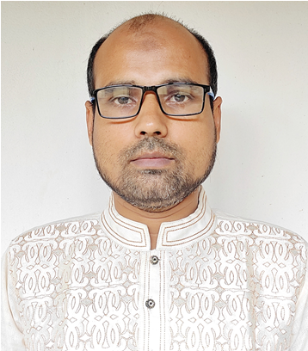
Resume
Md. Serajus Salahin
48, Dhaka Housing, North Adabor
Mohammadpur, Dhaka -1207
Cell: 01710-760909

Career Objective

To develop my interpersonal quality and job related skill I would like to major multinational or national organization and work with responsibility. More ever I am eligible for the position related to management & administration.

Experience
- Worked as an Asst. Accounts in Spectra Hexa Namsai co. Ltd. From December 2009 to March 2011.
- Worked as an Executive Finance & Accounts in Mim Fashion from May 2011 to till date.

Educational Qualification

Masters of Commerce (M.Com) in Marketing

Tejgaon College, Dhaka
2nd Class
Passing year 2007
National University, Bangladesh.

Bachelor of Commerce (B.Com)
Bodargonj Degree College Rangpur
3rd Class
Passing year 2003
National University, Bangladesh

Higher Secondary School Certificate
Bodargonj Degree College Rangpur
Commerce
2nd Division
Passing year 1999
Rajshahi Education Board, Rajshahi

Secondary School Certificate
Cantonment Board High School
Science
1st Division
Passing year 1997
Rajshahi Education Board, Rajshahi

Job Responsibility:
- Maintain Petty Cash & Cash Book.
- Prepare & Maintain Ledger Book.
- Maintain Bank Accounts & its related registers.
- Bill voucher prepare & check.
- Salary Sheet Preparation.
- Check daily Attendance & Leave.
- Maintain Client Bill, Quotation & Communications.

Skills:
- Having skills in team building.
- Good in working participatory approach.
- Having strong interpersonal skills, coordination & networking activities.
- Having creativity & think strategically.

Competencies:
- Technical knowledge.
- Building trust.
- Analytical & conceptual thinking.
- Commitment.
- Judgement.

Computer literacy:
- Microsoft Office (MS Word, Excel),
- Internet browsing.

Language proficiencies:
- Good in written and spoken in both English and Bangle.

Career Summary:
- More than 10 years working experiences of Accounts Management on different institutions. Excellent capabilities and skill in Accounts managing, controlling & monitoring.
Leadership and Self Management:
- Have excellent leading capability focus on result for the client and responds positively to feedback.
- Have bearing consistently approaches work with energy and a positive, constructive attitude.
- Demonstrates openness to change and ability to manage complexities.
- Manage the implementation strategies & operations in the working area as planned in the program.

Personal details:

Father’s Name : Late, Nurunnabi Lohani
Mother’s Name : Late Asufa Begum
Permanent Address : Protity Nikunjo
Road # ½, House # 66,
Wade No # 7, Baluavhata
P.S - Bodargonj.
Dist: - Rangpur.
Date of birth : 23rd February 1982.
Birth place : Bodargonj
Religion : Islam (Sunni).
Nationality : Bangladeshi. (By birth)
Sex : Male.

Reference by:

- H. Capt. (Rtd) Md Nurul Islam
Chairman
G7 Security Force Ltd.

2. Md. Faker Ahmed FCA
CFO
BDCom Online LTD.



………………
Md.Serajus Salahin

